1.61: a) Estimate the volume as that of a sphere of diameter 10 cm:
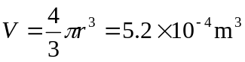
Mass is density times volume, and the density of water is 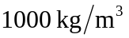, so

b) Approximate as a sphere of radius 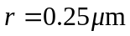 (probably an over estimate)
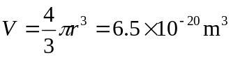

c) Estimate the volume as that of a cylinder of length 1 cm and
radius 3 mm:
